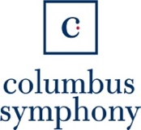

For Immediate Release Contact: Kelsi Moore

March 9, 2023 Kmoore@operacolumbus.org

**Grander Than Before, Opera Columbus and Columbus Symphony**

**Bring *Rigoletto* Back to Columbus**

*A “dream-like” collaboration between the Columbus Symphony and Opera Columbus allows for the grand return of a favorite Verdi opera*

*Columbus, OH* — For the first time in nearly a quarter century, *Rigoletto* will return in grand scale to Columbus thanks to a remarkable collaboration between Opera Columbus and the Columbus Symphony at the Ohio Theatre March 31 and April 1. Sparked by a mutual passion for grand opera, epic staging, and *Rigoletto* in particular, Opera Columbus’ Julia Noulin-Mérat and Columbus Symphony’s Rossen Milanov and Daniel Walshaw worked together to bring forward the biggest production Columbus has seen in years.

“Working together has been an absolute dream,” said Walshaw, Chief Operating Officer of the Columbus Symphony. “Julia, Rossen, and I shared a vision of bringing grand opera to Columbus, and we are over the moon to see this production come to life.”

In addition to the collaboration between their two cultural organizations, Walshaw and Noulin-Merat have also found great support with the Columbus Association for the Performing Arts (CAPA). *Rigoletto* will bring the opera from its home base of the Southern Theatre to the Ohio Theatre, with a larger seating capacity and orchestra pit.

“We have a fantastic partner in Rossen, Walshaw, and the Columbus Symphony,” said Noulin-Mérat, Opera Columbus’ General Director + CEO. “Because of this, we’re really able to expand the scale of the work here – everything is bigger, which is such a thrilling way to work. The sets and costumes are more ornate, we’re able to bring in singers from The Metropolitan Opera, even the theatre itself is bigger.”

A Verdi favorite, *Rigoletto* is set in the rich and decadent Italian Renaissance and features some of opera’s most famous arias. Rigoletto, a cursed court jester of the lustful Duke of Mantua, obsessively protects his daughter, Gilda. But when Gilda falls in love with the man her father loathes, Rigoletto’s thirst for vengeance and desperate attempt to stop fate bring about his own tragic undoing.

Milanov serves as musical director for the production, joined by Eve Summer as stage director. Milanov and Summer helm a cast including Aubry Ballaro, a District Winner in the 2022 Metropolitan Opera Laffont Competition, who makes both her Opera Columbus and role debuts as Gilda; Hyung Yun joins Opera Columbus for the first time singing the title role, which he recently covered at The Metropolitan Opera; and David Blalock, fresh off a run of *Dialogues des Carmelites* at The Metropolitan Opera, returns to Opera Columbus as the Duke of Mantua. The Columbus Symphony Orchestra plays both performances.

“We are thrilled to bring Eve Summer back as our stage director, following her incredible success and powerful storytelling with our *Tosca* last season,” said Noulin-Mérat, “Our M*aria de Buenos Aires* was our biggest box office hit in 10 years and our *Alice Tierney* sold out in two days, this is a record-breaking season for us all in Columbus, making *Rigoletto* a must-see show of the year.”

*Rigoletto* will be performed in Italian with English supertitles at the Ohio Theatre March 31 and April 1 at 7:30 p.m. Performances run approximately 2 hours and 20 minutes with one intermission. Ticket prices range from $9.84 - $88.50. For tickets and additional information, please visit <https://www.operacolumbus.org/rigoletto/>.

**###**

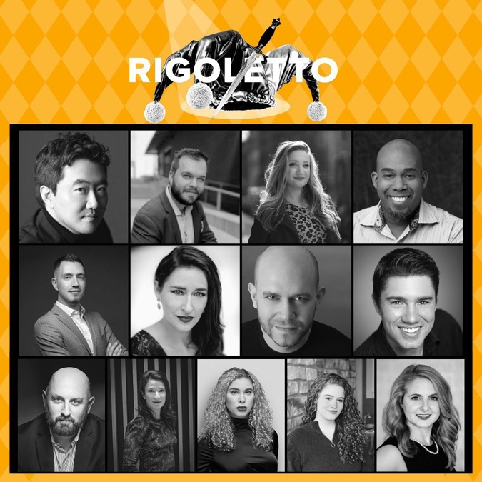**CAST & CREATIVE**

Rigoletto: Hyung Yun; Duke: David Blalock; Gilda: Aubry Ballaro; Monterone: Eric McKeever; Sparafucile: Cody Muller; Maddalena: Hilary Ginther; Marullo: Robert Kerr; Borsa: Ben Bunsold; Ceprano: Darren Templeton; Giovanna: Anabella Petronsi; Countess Ceprano: Hannah Bullock; Page: Sophia Longo; Courtesan: Alison Steiner

*Chorus:* Michael Kirkman, Ryan Kopycinski, Colton Weiss, Javier Lopez Rosa, Michael Ruehrmund, Billy Edwards, Scott Green, J’Von Jones, Ryan Patrick Jones

*Courtiers*: Marcus Charleston, Ainsley Savage, Laura Less Jingo, Stephen Hanna, Birtie Floyd, Camel Sanders, Emma Rose Lewis, Lindsey Capritta, Frank Juodyalkis

Eve Summer, Director; Rossen Milanov, Conductor; Andres Lopera, Assistant Conductor; Sarah Danhke, Crane Directing Fellow; Eric Fielding, Set design; Neil Fortin, Costumes; Marcella Barbeau, Lighting; Lonelle, Props

**About Opera Columbus**

Under the vision of General Director + CEO, Julia Noulin-Mérat, Opera Columbus is redefining and reimagining the concept of regional opera with world-class productions that celebrate extraordinary talent and artistic partnerships, engaging a new, diverse audience for this most magnificent of artforms. From groundbreaking collaborations to innovative and breathtaking productions, Opera Columbus is passionate about creating artistic moments for each and every patron since 1981. Opera Columbus’s slogan, “Make It Yours,” demonstrates the company’s commitment to inclusivity, and invites everyone in the community to join with us.

Opera Columbus is additionally grateful for the support of AEP, Cardinal Health, The Columbus Foundation, Cult Marketing, Greater Columbus Arts Council, Nationwide, National Endowment for the Arts, Ohio Arts Council, and The Ohio State Wexner Medical Center-Voice Center.

**About Columbus Symphony**

Since 1951, the Columbus Symphony (CSO) has been proud to serve as central Ohio’s flagship music performance organization. The CSO’s musicians, conductors, chorus, and world-renowned guest artists enrich the central Ohio community through extraordinary talent, passion, dedication, and the highest standards of musicianship. Living and working in the community, CSO musicians are interwoven throughout the region’s cultural fabric, accompanying performances by other companies, performing in other local orchestras, and teaching and coaching young musicians. Guided by the artistic vision of Music Director Rossen Milanov, the CSO offers four programming areas – Masterworks, Pops, Picnic with the Pops, and Education/Community Engagement – that are targeted to appeal to diverse audiences throughout central Ohio. This segmented approach, innovative within the American orchestra industry, is helping the CSO to reach new, younger, and more diverse audiences.

**###**