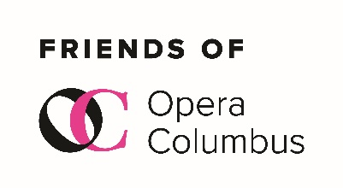

**MEMBERSHIP APPLICATION**

**2024-2025 Program Year**

**NAME**(s)____________________________________________________­­_____________

Address_________________________________________________________________

Home Phone(s)___________________________________________________________

Cell Phone(s)_____________________________________________________________

Email(s)_________________________________________________________________

**DUES**

**Regular Membership $45 per person**

**Sustaining Membership $75 per person**

**TOTAL PAYMENT ENCLOSED** ____________________

**Return this form and your check made payable to**

**Friends of Opera Columbus**

**Send to:**

**Ken Fultz, Treasurer**

**1284 Wedgefield Lane**

**New Albany, OH 43054**

*Friends of Opera Columbus supports the growth of Opera Columbus, awareness of opera in general, helps raise funds for Opera Columbus and serves our membership with special events such as fundraisers, excursions, pre-opera dinners and social gatherings.*